CSC8502 Coursework Read Me

Student Name: Ziye Chen (PGT)

Student No:230249572

Video link: https://youtu.be/pOQqg4UYT8A

Instructions

|  |  |  |
| --- | --- | --- |
| ↑:KEYBOARD_UP | The character moves forward | If your character walks out of the map, it's game over. (Actually, because the y-axis of the character standing needs to be passed into the heightmap X and Z. There is no heightmap X and Z information outside the map, so the program ends. I should limit it, but that's not cool). |
| ↓:KEYBOARD_DOWN | The character backs away |  |
| ←:KEYBOARD_LEFT | The character shifts left |  |
| →:KEYBOARD_RIGHT | The character shifts right |  |
| W: KEYBOARD_W | The camera moves forward |  |
| S: KEYBOARD_S | The camera backs away |  |
| A: KEYBOARD_A | The camera shifts left |  |
| D: KEYBOARD_D | The camera shifts right |  |
| Q: KEYBOARD_Q | The camera rises |  |
| E: KEYBOARD_E | The camera descends |  |
| SHIFT: KEYBOARD_SHIFT | rotation around the axis of camera |  |
| SPACE: KEYBOARD_SPACE | rotation around the axis of camera |  |
| 1: KEYBOARD_1 | Switch of the camera moving | (Keyboard input may be triggered multiple times with a single click. The same bad situation is same to 2 and 3) |
| 2: KEYBOARD_2 | Switch of third-person perspective of character | Toggling the third-person view automatically turns off camera movement.  Camera movement cannot be turned on when the third-person view. |
| 3: KEYBOARD_3 | Position to the long lens | Toggling to the long lens automatically turns off camera movement and third-person perspective. |

1. The overall scene on the ground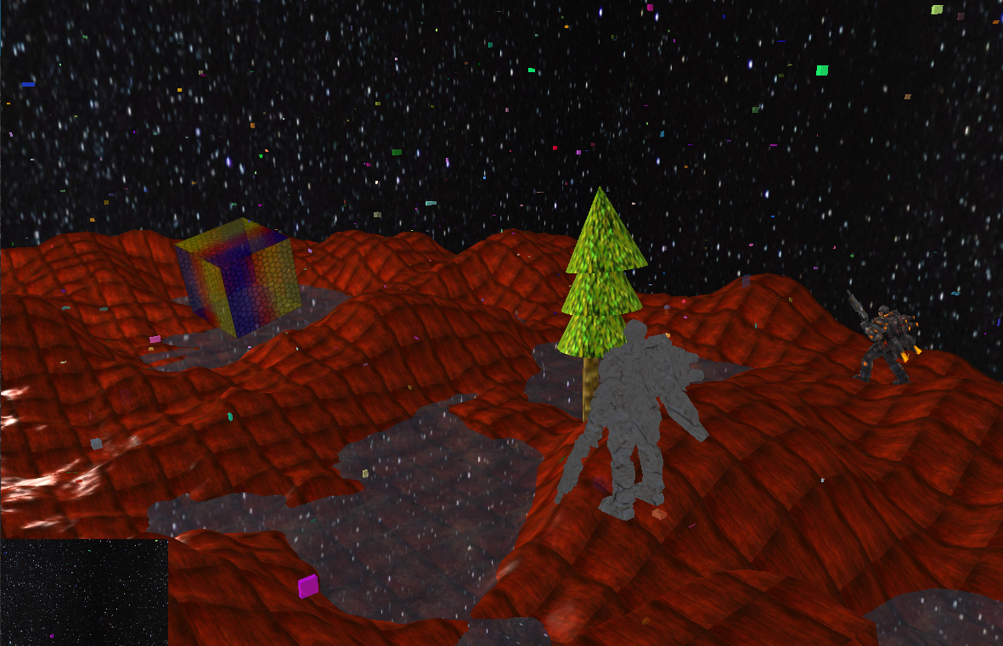

2. Perspective cubes

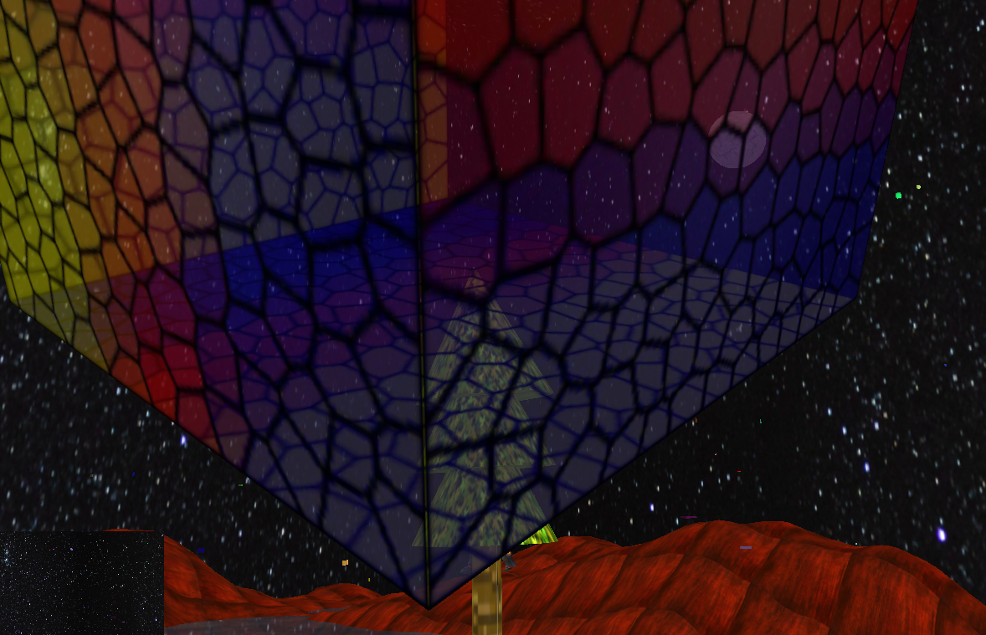

3Shadow from sun

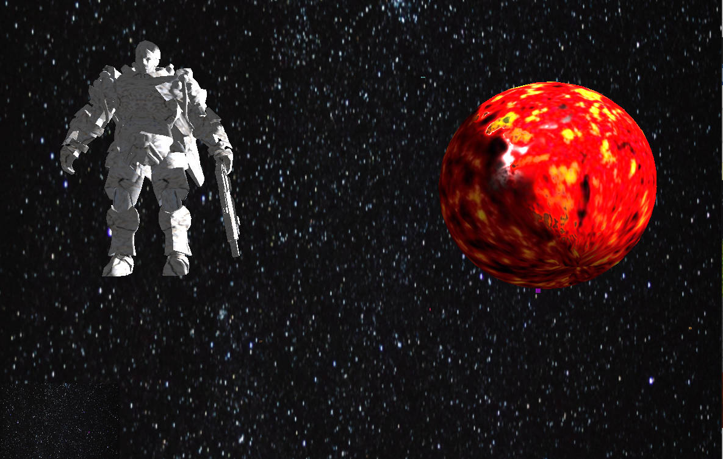

4 skeletal animation tree of your own design

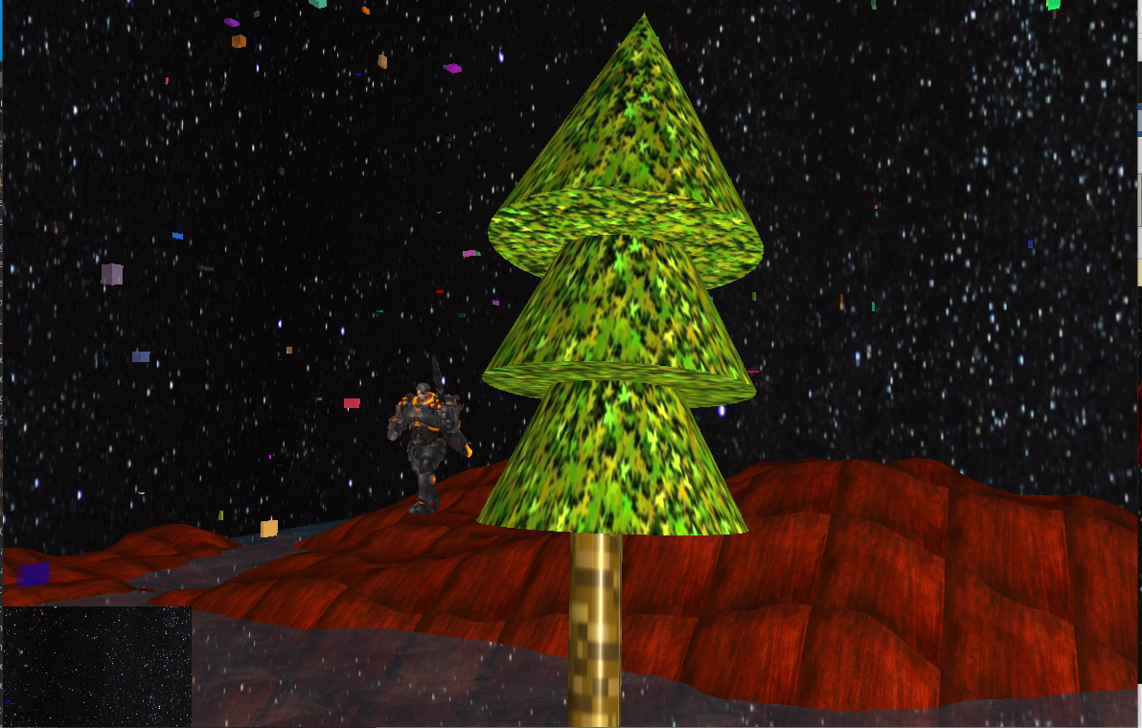

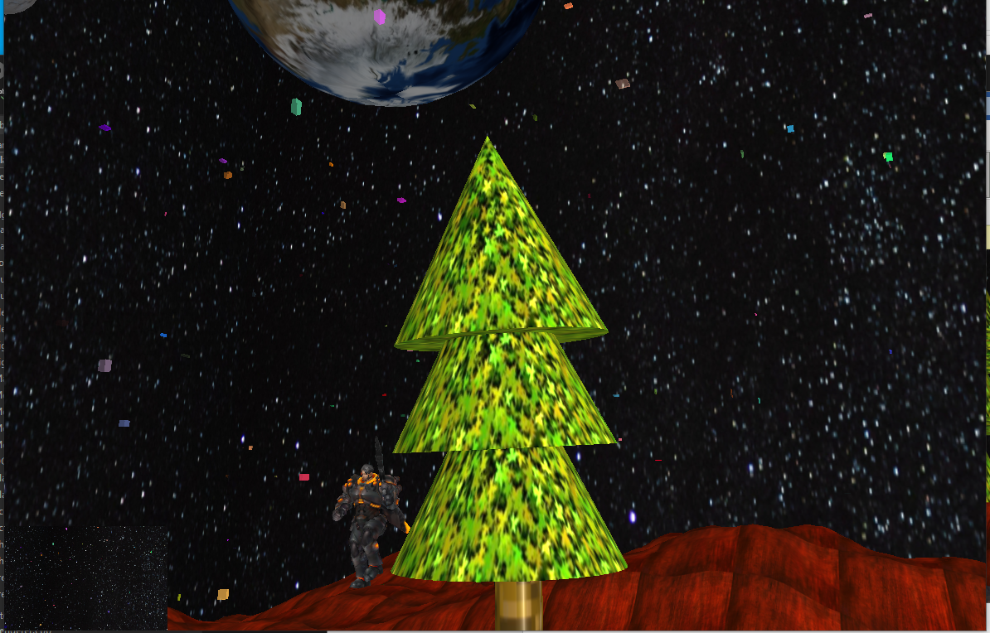

5.star, moon and earth;

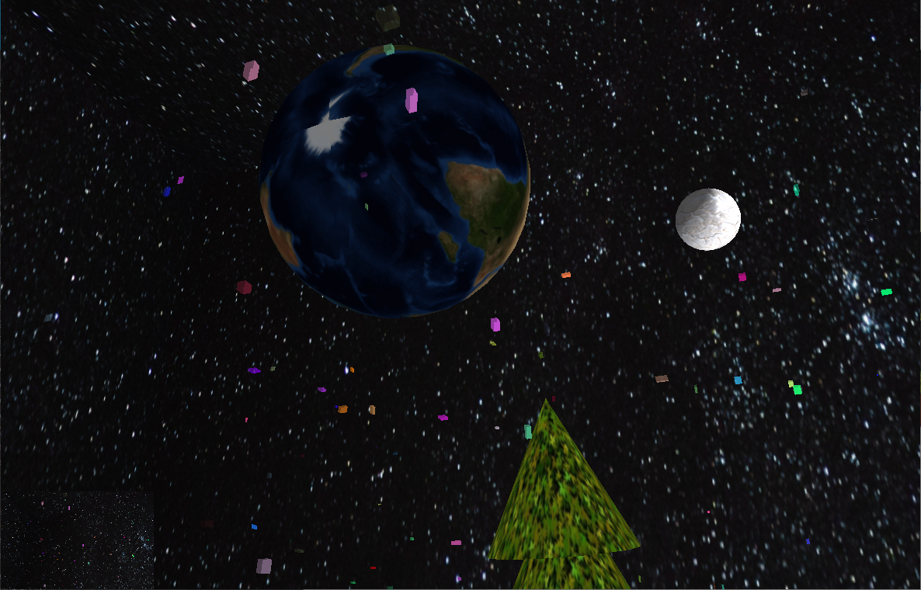

6. Multiple viewpoints of star twinkling

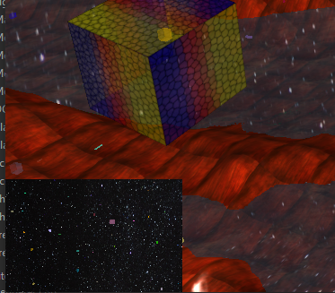

7. Day and night switch with the revolution of the sun

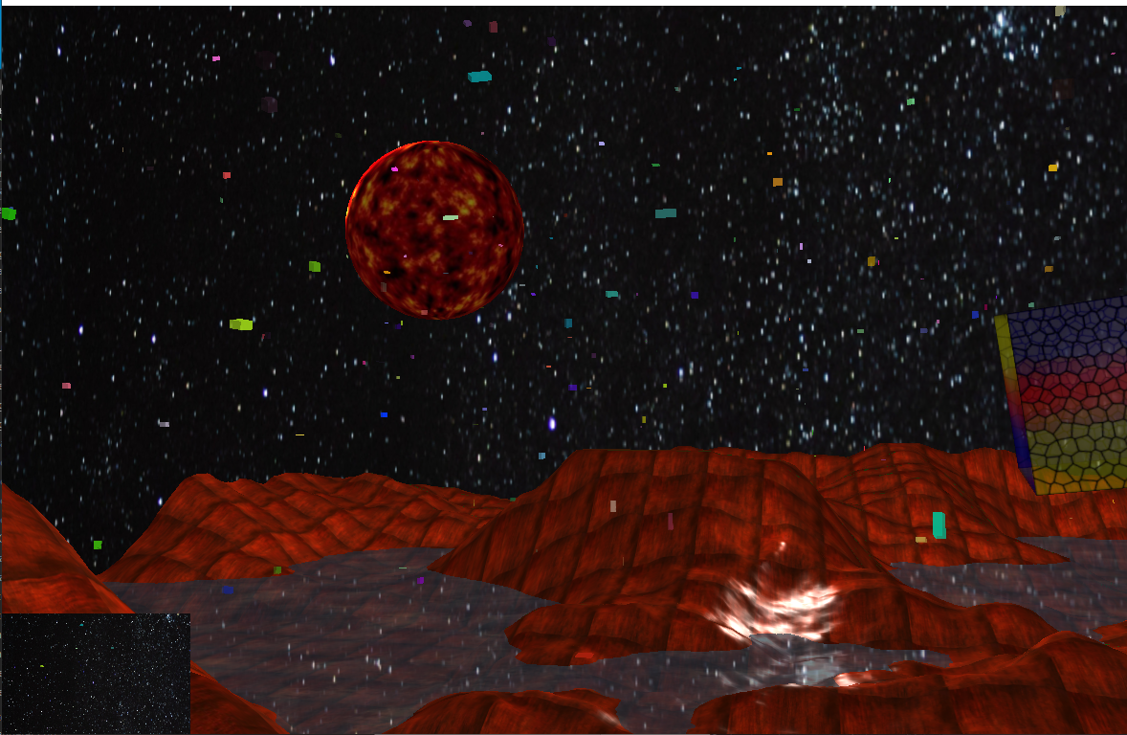

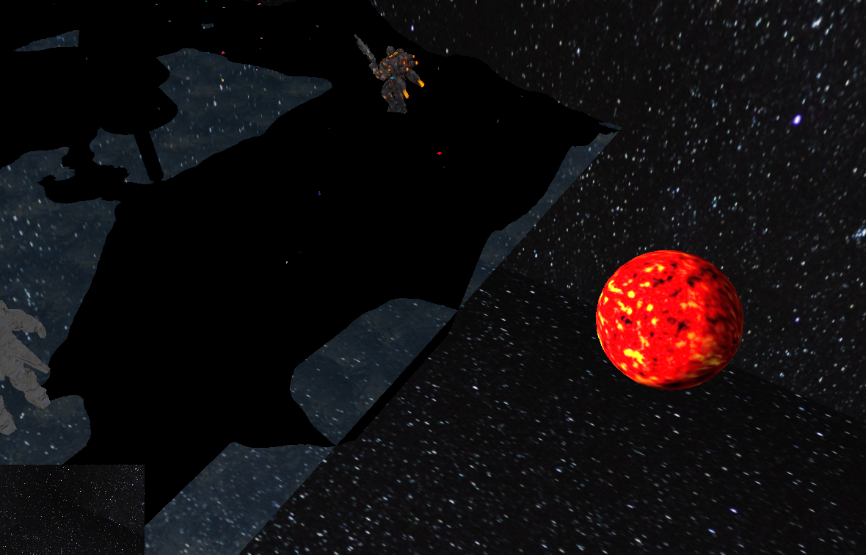

8. Third-person view and character controls

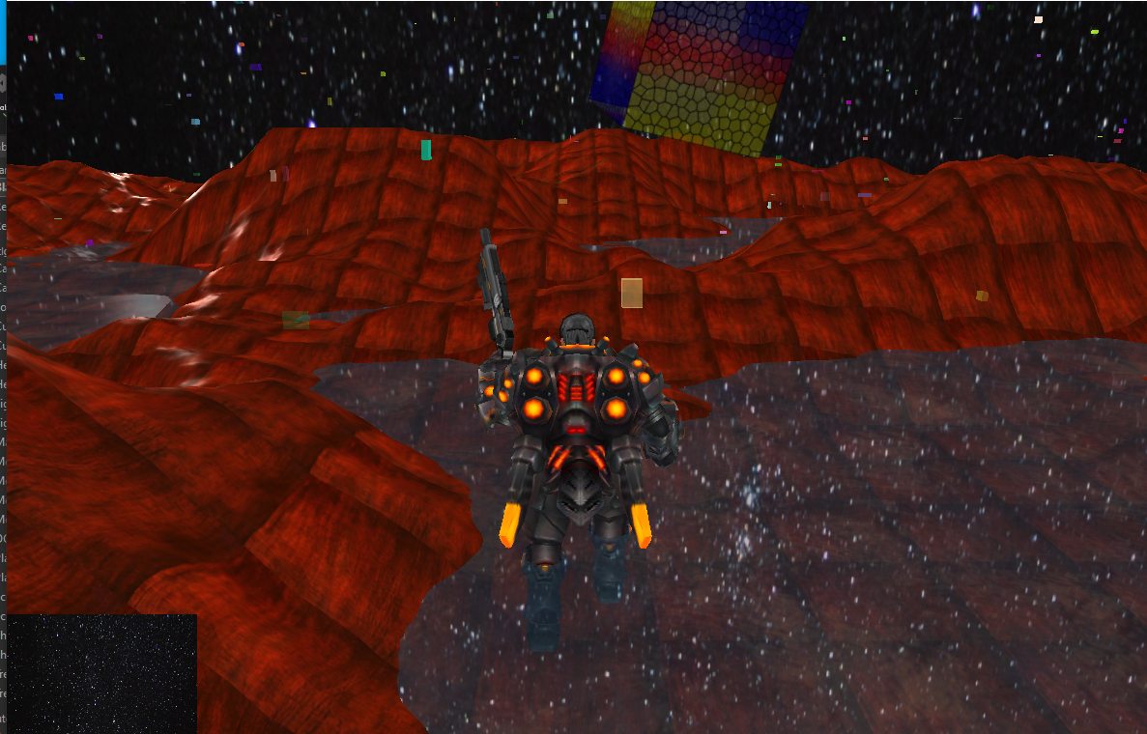

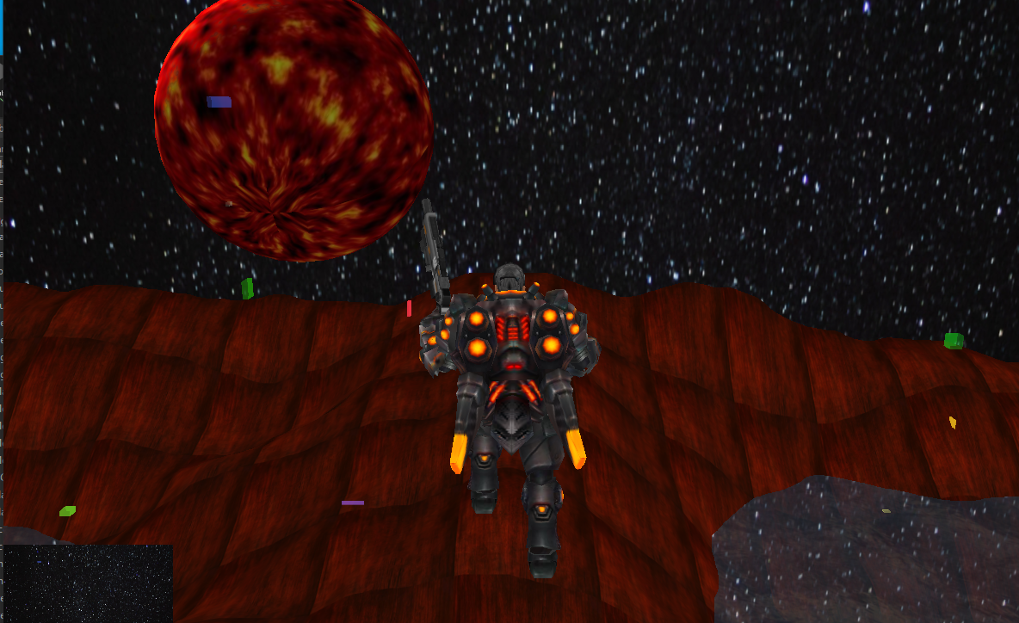

9. Long-range shots

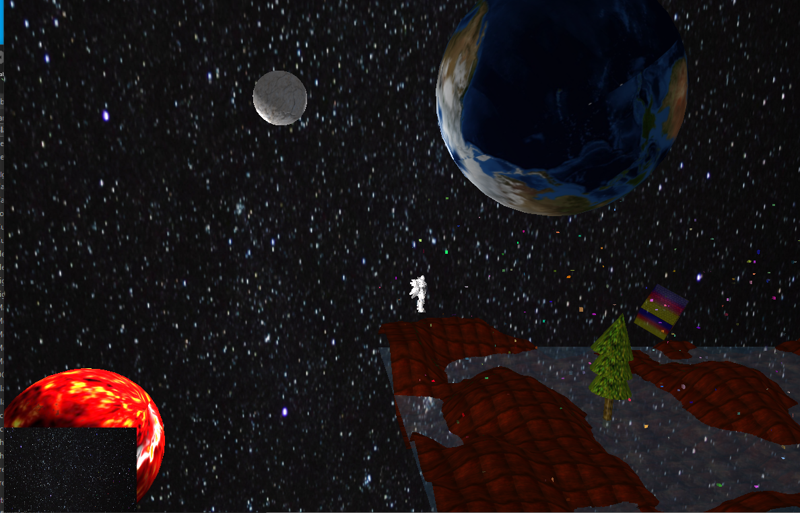

10 Tidal movements

